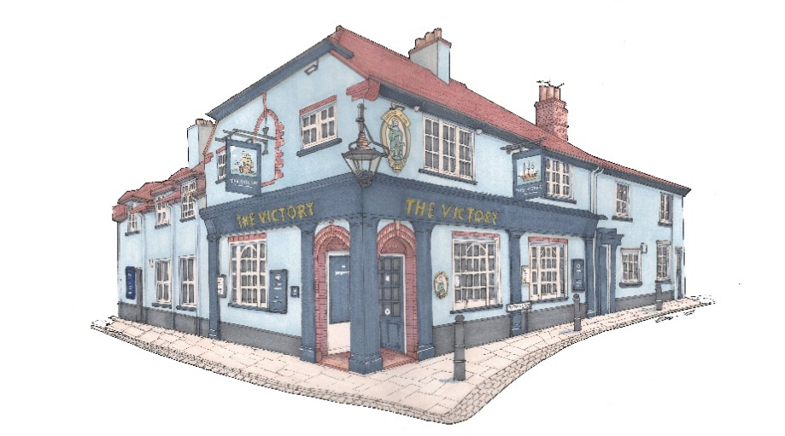

Small plates £9
Salmon & dill fishcakes, mustard mayo (GF)
Tomato, ginger, chilli & coriander soup (V) (GF)
King prawns in garlic butter (GF)
Smoked salmon, pickled cabbage, sesame, soy dressing (GF)
Beef carpaccio, parmesan, watercress (GF)
New Zealand green lip mussels, coconut & coriander (GF)
Deep fried camembert, cranberry (V)
Sweet chilli chicken wings (GF)
Deep fried whitebait, tartare sauce
BBQ ribs (GF)
Duck rillette & apricot jam, toast
Honey & herb Chipolatas
Paprika smoked chicken goujons, sweet chilli (GF)
Cod goujons, tartare sauce (GF)
Vegetable spring rolls, soy dressing (V)
Sauté wild mushroom en croute (V)

ANY 3 FOR £22

Signature Dishes
Chargrilled ribeye steak, sauté potatoes, wild mushrooms, tomatoes & garlic butter (GF) £30
Roasted loin of cod, seafood stew, samphire & salsa verdé (GF) £25
Roast haunch of venison, fondant potato, braised red cabbage, red wine & juniper (GF)
£24
Pea & mint risotto, watercress and parsnip crisps (V) £19
Please advise your server of any food allergies or intolerances.
* Gluten free option available *

